**The right cell for the job**

**Animal cells**

The diagrams all show animal cells.

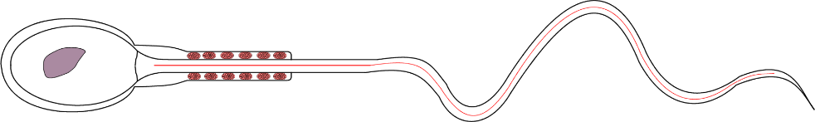

nucleus

whip-like tail

mitochondria

0.05 mm

**Cell A**

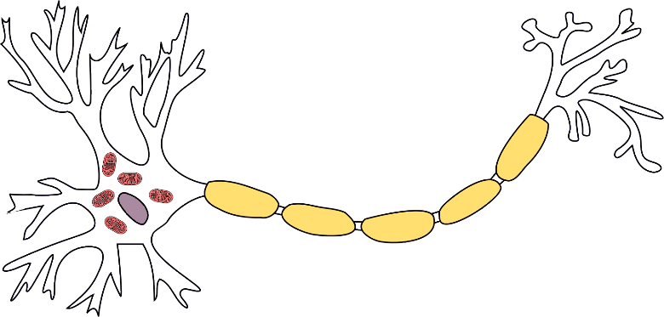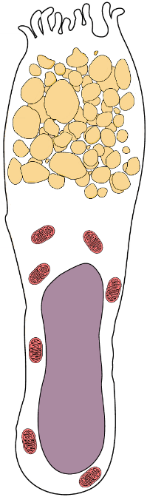

Can be up to 2 m long

0.04 mm

**Cell B**

mitochondria

mucus vesicles

fatty insulation

cytoplasm

cell membrane

**Cell C**

**To discuss**

1. Which cell would be best for transmitting electrical nerve impulses from the toes to the brain?
2. Which cell would be best for swimming towards an egg cell to fertilise it with genetic material?
3. Which cell would be best for lining the inside wall of the intestines to protect it from damage?

Make sure you can explain why you chose each cell.

**The right cell for the job**

**Plant cells**

The diagrams all show plant cells.

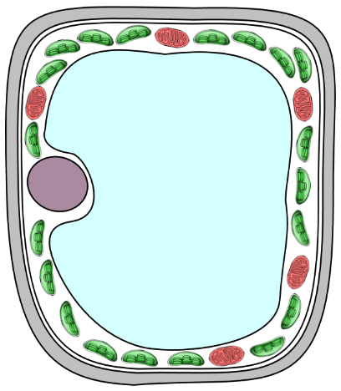

Vacuole can fill with water to make the cell swell up

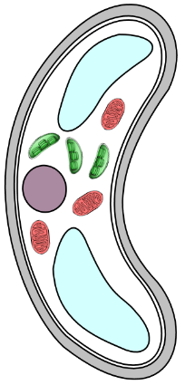

nucleus

**Cell A**

chloroplasts

cell wall

0.01 mm

0.02 mm

hole

**Cell B**

(two cells work as a pair)

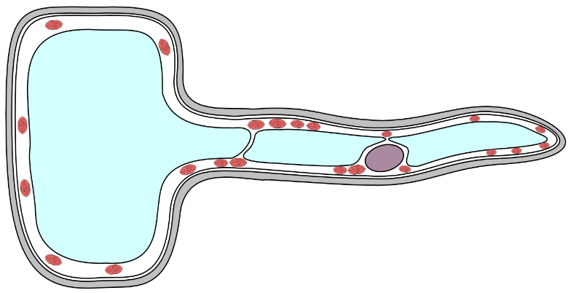

**Cell C**

mitochondria

cytoplasm

cell membrane

Can be up to 1.5 mm long

**To discuss**

1. Which cell would be best for making food by photosynthesis in a leaf?
2. Which cell would be best for lining the outside of a root to absorb water from the soil?
3. Which cell would be best for controlling the movement of gasses into and out of a leaf?

Make sure you can explain why you chose each cell.

*Biology > Big idea BCL: The cellular basis of life > Topic BCL1: Cells > Key concept BCL1.3: Cell shape and size*

|  |
| --- |
| **Response activity** |
| **The right cell for the job** |

**Overview**

|  |  |
| --- | --- |
| Learning focus: | Cells are usually too small to be seen without a microscope, but have a range of three-dimensional shapes and sizes. |
| Observable learning outcome: | Link the shapes and sizes of different cells to their functions. |
| Activity type: | Discussion |
| Key words: | cell |

This activity can help students’ conceptual progression by addressing misunderstandings about the variety of sizes and shapes of cells that make up organisms, as revealed by the following diagnostic question:

* Diagnostic question: The size and shape of cells

**What does the research say?**

Clément (2007) notes that “the cell concept is generally introduced by two juxtaposed drawings, a plant cell and an animal cell”, and that the plant cell is generally polygonal and adjacent to other cells while the animal cell is more rounded in shape and isolated. Clément has dubbed the common depiction of an animal cell as two concentric circles (cell membrane and nucleus, lacking other organelles or internal structures) the “fried-egg model”, and has shown that it can block subsequent development of understanding (e.g. about cell differentiation).

If students are not presented with a greater variety of images of cells they may come to think that all animals cells and all plants cells have the same shape and structures as these two archetypal depictions; Clément found exactly this misunderstanding persisting in students up to undergraduate level.

Several researchers have reported that children aged 11-16 lack an appreciation of size and scale, manifested in their assumption that atoms, molecules and cells are all the same size. This conflation has been dubbed “the molecell” (Arnold, 1983; Dreyfus and Jungwirth, 1988).

**Ways to use this activity**

Students should complete this activity in pairs or small groups, and the focus should be on discussion to reach a consensus decision and explanation (it is through the discussions that students can check their understanding and develop their explanations). Students should work together to follow the instructions on the worksheet or the presentation.

Giving each group one worksheet to complete between them is helpful for encouraging discussion, but each member should be able to report back to the class. Listening in to the conversations of each group will often give you insights into how your students are thinking.

Alternatively, you may wish to divide the class into “expert groups”, with some groups discussing the animal cells and other groups discussing the plant cells. The groups could then be rearranged into “jigsaw groups” such that there is a mixture of animal and plant “experts” in each groups, who must then report back on their group’s decisions and explanations.

**Expected answers**

*Animal cells*

1. Cell C (nerve cell)
2. Cell A (sperm cell)
3. Cell B (goblet cell)

*Plant cells*

1. Cell A (palisade mesophyll cell)
2. Cell C (root hair cell)
3. Cell B (guard cell)

Students are not expected to identify the specific cell types, and the names of the cells have deliberately been omitted from the student-facing materials to avoid giving clues as to the answers; students should make their decisions based on the cell features.

**Acknowledgments**

Developed by Alistair Moore (UYSEG).

Images: mitochondria – Wikimedia Commons/Nevit (adapted by UYSEG); neuron – Wikimedia Commons/Quasar Jarosz (adapted by UYSEG); goblet cell – Wikimedia Commons/OpenStax College (adapted by UYSEG); spermatozoon – Wikimedia Commons/Mariana Ruiz Villarreal (adapted by UYSEG); chloroplasts – pixabay.com/Clker-Free-Vector-Images (35023) (adapted by UYSEG); all other drawings – UYSEG

**References**

Arnold, B. (1983). Beware the molecell! *Biology Newsletter,* 42**,** 2-6.

Clément, P. (2007). Introducing the cell concept with both animal and plant cells: a historical and didactic approach. *Science & Education,* 16(3-5)**,** 423-440.

Dreyfus, A. and Jungwirth, E. (1988). The cell concept of 10th graders: curricular expectations and reality. *International Journal of Science Education,* 10(2)**,** 221-229.